HANDOUT PACKET

EXAM 3

PHYSICAL GEOGRAPHY

THERKALSEN

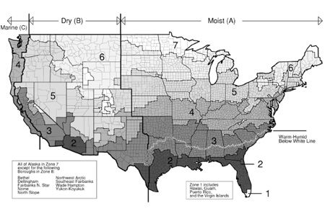

GLOBAL PRESSURE BELTS AND CLIMATE
DATE:_________
Solar Declination: __________
Pressure Shifts __________

0°
30°N
60°S
90°S
90°N
60°N
30°S
0°
30°N
60°S
90°S
90°N
60°N
30°S
0°
30°N
60°S
90°S
90°N
60°N
30°S
DATE:_________
Solar Declination: __________
Pressure Shifts __________
DATE:_________
Solar Declination: __________
Pressure Shifts __________

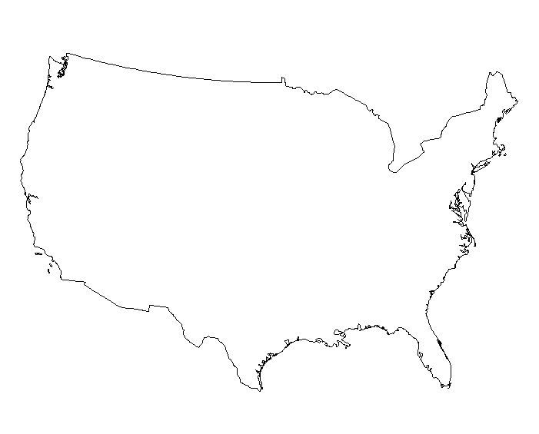
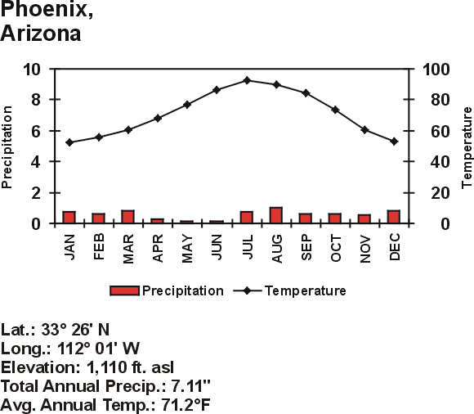
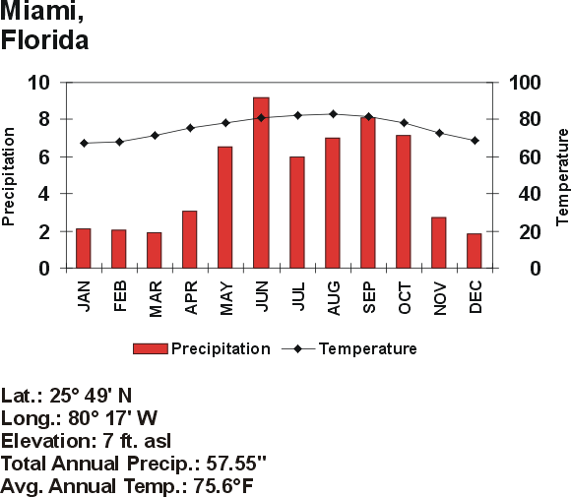
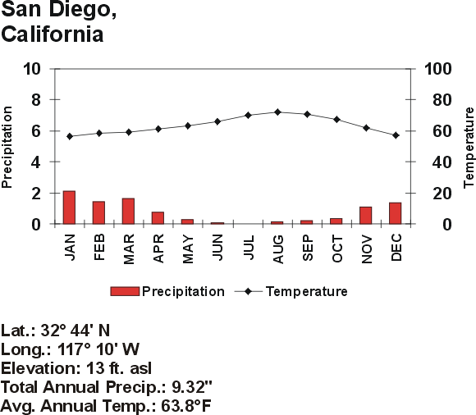
US CLIMATES
CLIMATE NAME:
LOCATION
CITY:

CLIMATE NAME:
LOCATION
CITY:

CLIMATE NAME:
LOCATION
CITY:

CLIMATE NAME:
LOCATION
CITY:

US CLIMOGRAPHS

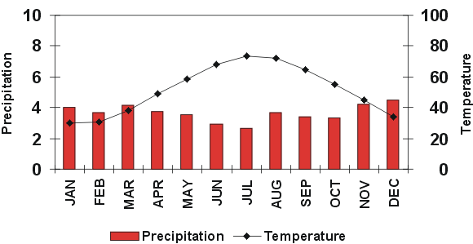

CLIMATE AND VEGITATION CONCLUSIONS (test your understanding):
The 6 climate controls we discussed in class are ____________, ____________, _____________, _____________, ________________, _______________. Insolation stands for ___________ ____________ _____________ and it is hugely influential in the determination of temperature and climate. Total insolation is based mainly upon 2 variables: ___________ and ____________ and these vary based upon ___________ as a result of the earth sun relationship. Thus, we can conclude that _________ latitudes have a warmer annual temperature and a _________ temperature range. The seasons on earth are caused by the changing relationship between the earth and the sun.
Another important component of atmospheric heating is caused by gases in the atmosphere trapping energy and reradiating it back to earth, this is referred to as the ____________ effect and it is a _____________ (positive or negative) thing for humans. Often confused global warming is actually caused by an _____________ greenhouse effect when too much heat is trapped within the atmosphere.
Another important climate control is the principle of continentality which states that _________ locations have a lesser annual and ___________ temperature range than ___________ locations, or basically that inland locations have more ____________ temperatures. Climate may also be influenced by elevation. For example, as altitude ______________ temperature decreases and precipitation ______________. Thus higher locations tend to be ____________ and ___________ than surrounding areas. Speaking of elevation mountains also may act as a barrier to ___________ and influence temperature as air rises and sinks. As a result the windward side of a mountain is usually _______ wet than the leeward side which is usually very ________; this phenomenon is referred to as the ______________ effect.
Ocean Currents are also highly influential. As a result of the rotation of the earth ocean currents flow in a _______________ direction in the Northern hemisphere and a _________________ direction in the southern hemisphere. This causes _________ coast locations everywhere in the world to receive warm water currents and thus have _________ temperatures, more humidity, and ____________ precipitation. Meanwhile west coast locations receive ________ water currents and thus tend to have ___________ temperatures, and much less ____________.
The last control on climate we spoke of was global wind and atmospheric pressure. We discovered that air flows from _________ pressure to _________ pressure and that _________ pressure is associated with rising air and thus clouds and precipitation while _________ pressure is associated with sinking air and thus clear skies and no precipitation. The global pressure pattern indicates that there is usually low pressure over the equatorial regions and this explains why there are usually very __________ levels of precipitation. While ________ pressure centered at 30°N and S should indicate ________ skies and ________ precipitation. High pressure at the poles also leads to little precipitation and ________ pressure centered around 60°N and S brings more weather and precipitation. These global wind and pressure belts also shift seasonally along with the ___________ ____________; this is important to understand because it leads to a shift in the direction of winds, referred to as the ______________ which can bring drastic changes in precipitation integral to life in many places.
As a result of our understanding of climate we can make the following classifications regarding global climates and vegetation:
Tropical climates (A): 25°N-25°S; warm, moderate/abundant precip. and ___________ or ______________type vegetation.
___________ Climates (C): 30-60°N and S; ___________; moderate/abundant precip; mixed forest vegetation.
Dry Climates (B): 30°N and South, ________ coast; hot, _________ precipitation as a result of the ________ ocean current; desert/scrub vegetation.
Severe mid latitude (D): 50-70°N and S; extreme winters; ___________ forest vegetation
________ Climate (E): 70-90°N and S; always cold _________/ice caps.

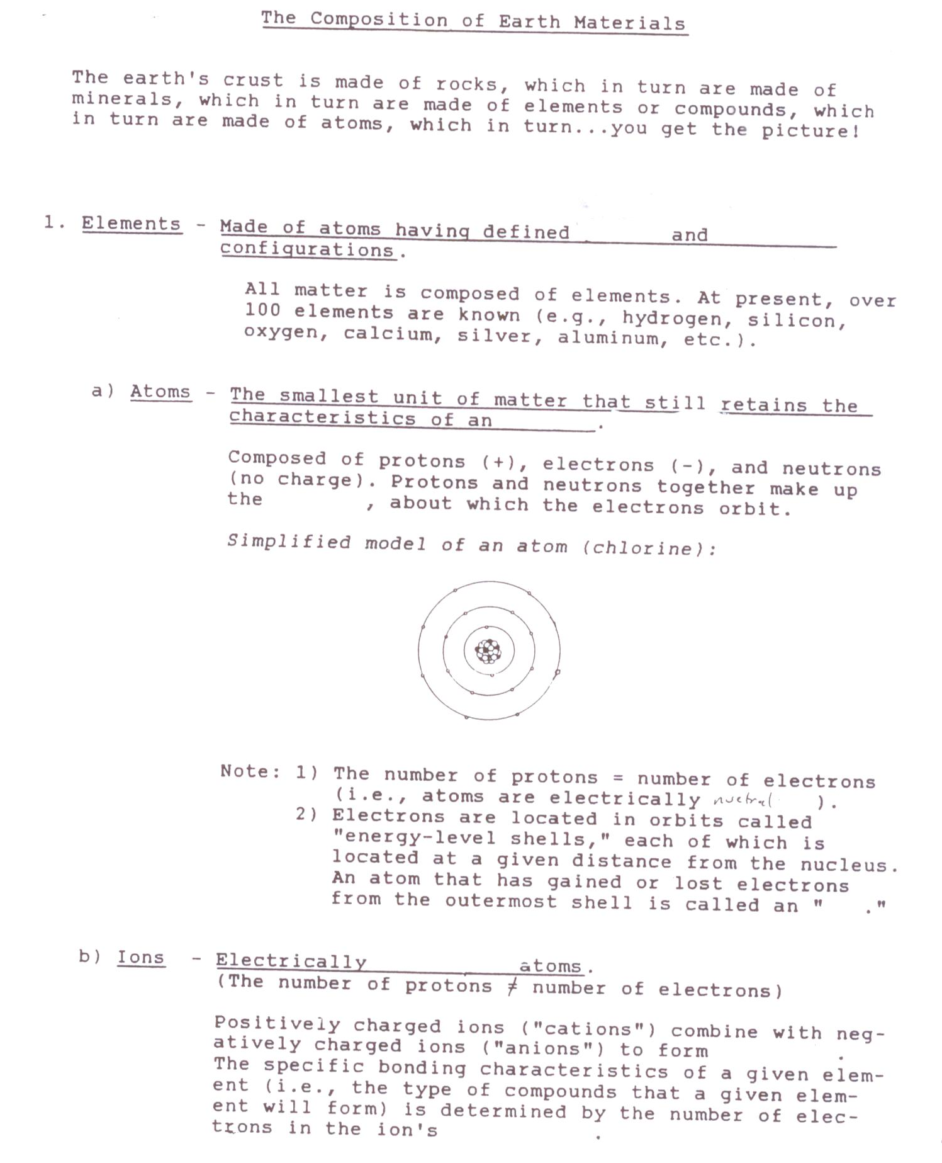
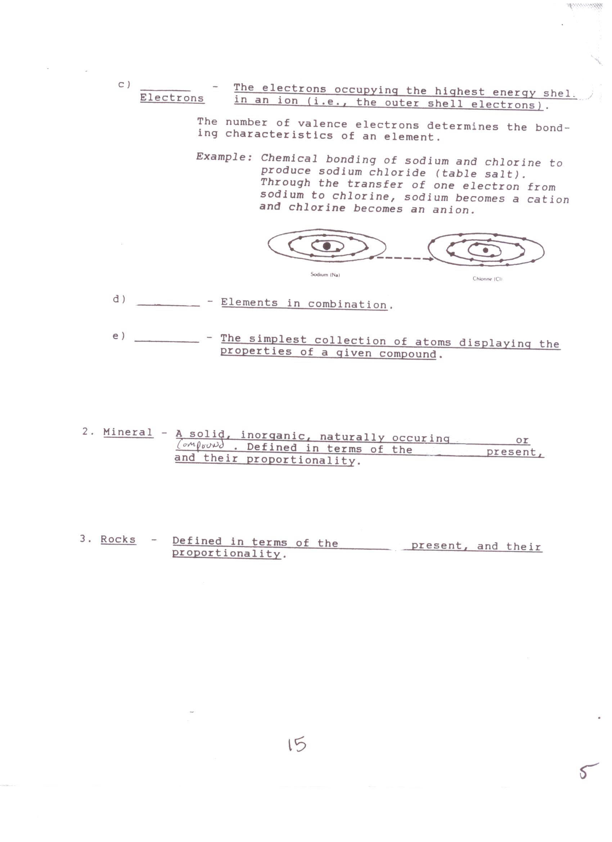
PALEOZOIC ERA
T1:___________________________
MESOZOIC ERA
T2:___________________________
EARLY CENEZOIC ERA
T3:_____________________________________
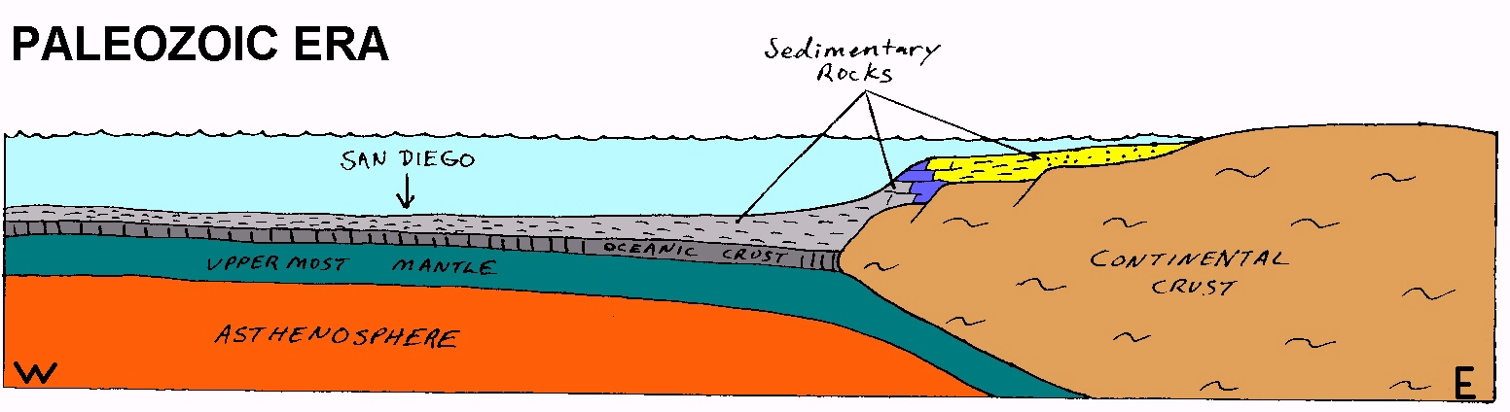
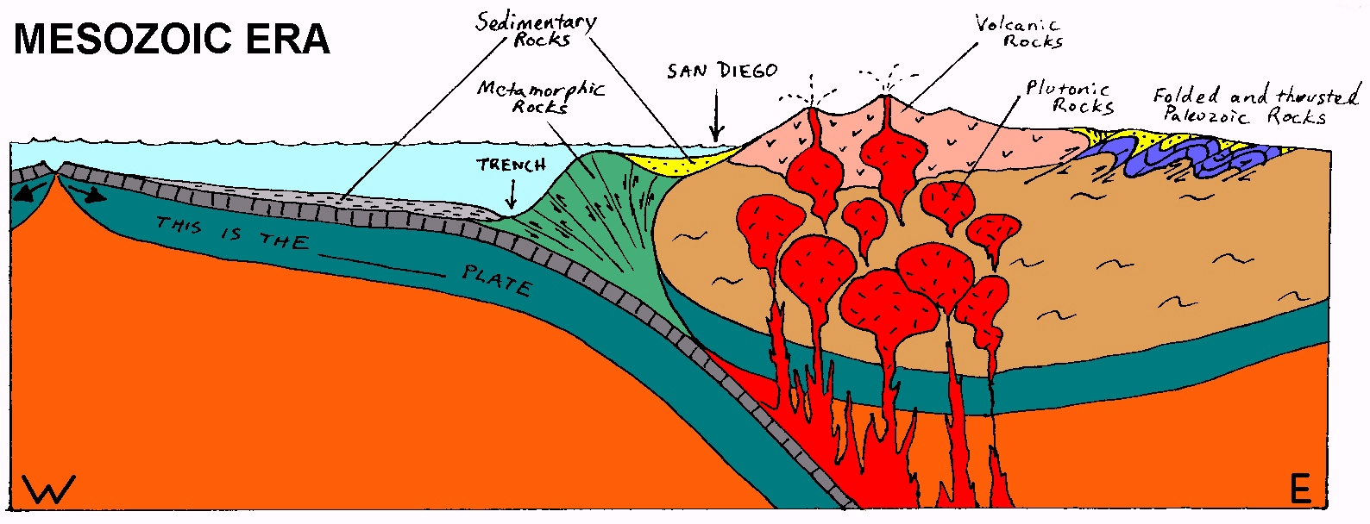
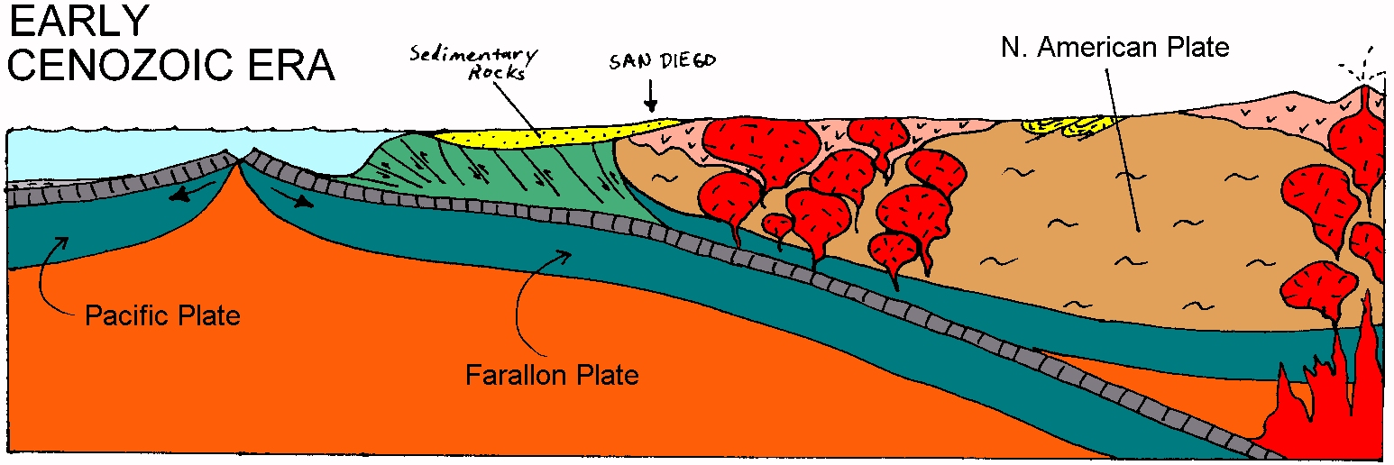
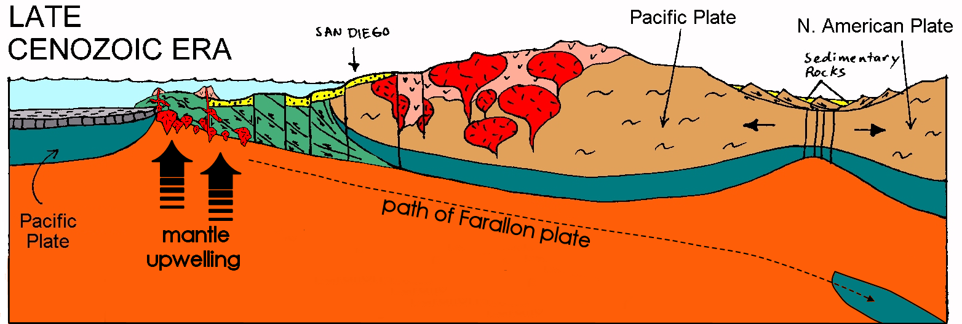
LATE CENEZOIC ERA
T4:_____________________________________
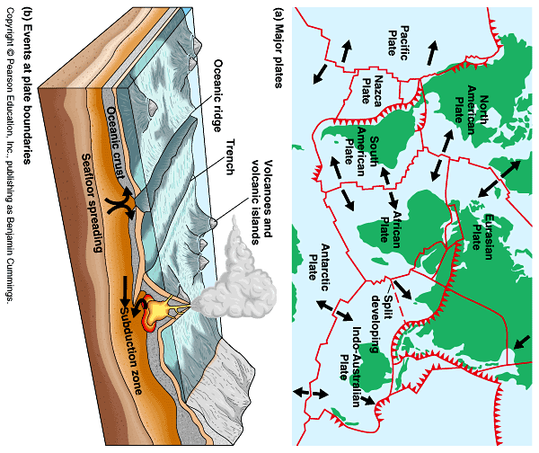

REVIEW QUESTIONS FOR TEST NUMBER ONE:
Rewrite and answer all of the following questions in detail for extra credit.
CLIMATE
1. How is climate defined?
2. What types of measurements is climate based upon/how is average weather measured?
3. What is a moist Vs a dry climate? What are regional moisture inputs/outputs?
4. What were the six climate controls we spoke about in class? Also, you should explain how each of these act as a climate control as opposed to just memorizing the list.
5. How do global wind and pressure belts effect climates?
6. Draw the profile view of global wind and pressure and explain why the wind and pressure belts occur as they do AND explain how these contribute to the type of climates found at certain latitudes?
- What are the results as these belts shift
7. According to the profile view and the idealized earth (no land) what types of climates can we expect to find at 0°, 30°, 40-60°, and 90°; sketch the “idealized earth (without land).”
8. How does climate change with elevation?
9. What were the latitudinal climate characteristics we discussed in class for:
1. Low latitudes
2. Sub-tropical latitudes?
3. Mid-Latitudes (east/west/continental)?
4. High Latitudes?
5. And highlands?

10. More importantly, WHY can we expect these latitudes to have these characteristics?
11. Draw the idealized continent we drew in class ALSO EXPLAIN WHY you expect to find these climates where you do (i.e. speak to the principle of continentality, ocean currents, pressure , air mass movement, etc.) rather than just memorizing locations!
12. What is a climograph? How do you read a climograph? Why are climographs useful?

13. Identify the following climographs (and then look for more practice through our website).
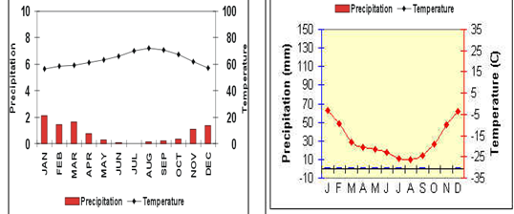
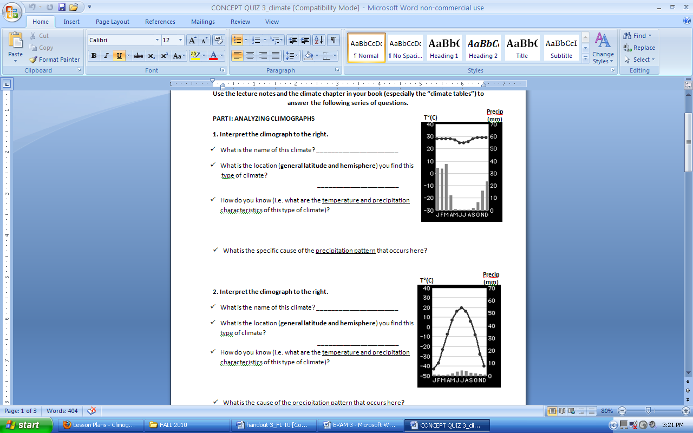
- Ask yourself some general questions: is there a lot of rain, Is the rain year round, is it always hot, is there a great temperature variation, when is the warm season, etc.).
14. What does the climate distribution of North America look like? WHY do you find the climates that you do in the places that you do? Sketch and explain.
BIOSPHERE
1. What is Biogeography?
2. What is an Ecosystem/Biome/Habitat?
3. What determines a Biome? How is each classified? And what do the species look like?
4. What is the primary component of any biome, ecosystem or habitat?
5. Why are plants so important? What makes them different than other organisms?
6. What is the food chain, in the deeper way we described it?
7. What is photosynthesis, basically, and in terms of the chemical formula?
8. What is respiration, basically, and in terms of the chemical formula?
9. How are the two above processes related?
10. Why is it important to understand respiration? What is the important byproduct, how is that related to the food chain and us?
11. What determines the number of animals in any Biome?
12. What determines the number of plants in any biome?
13. In what two ways are Biomes classified? Explain each.
14. What types of places/climates do we expect to be most productive/least productive?
15. What is evolution/natural selection/adaptation? How are these related to this course and the organisms we expect to find in certain biomes?
16. Describe the latitudinal distribution of biomes.
- What types of plants do you expect to find where and WHY?
- What adaptations have been developed in different biomes?
17. Describe the relationship between elevation and climate. How do climates change throughout San Diego?
18. What are the variables that determine where different biomes are found throughout the world?
EARTH MATERIALS
1. Sketch the composition of the Earth in terms of the three layers we discussed in class.
2. What is the Asthenosphere? The Lithosphere? Where are they?
3. What is the difference between oceanic and continental crust?
4. When was the earth formed?
5. What is the era of time that we are currently in?
6. What is the crust made of? What are minerals made of? What is an element?
7. What is the difference between a mineral and a rock?
8. How do rocks vary/how are rocks classified or named?
9. What is the rock cycle?
10. What are the three main types of rocks?
11. How are igneous rocks formed?
12. Compare and contrast intrusive igneous rocks and extrusive igneous rocks. How is each formed? How does this influence their appearance? What is an example of each?
13. What is the difference between magma and lava?
14. What is the difference between shield volcanoes and strato or composite volcanoes?
15. How are sedimentary rocks formed?
16. What are the characteristics of sedimentary rocks?
17. How are metamorphic rocks formed?
20. Compare and contrast the three major rock types.
Plate Tectonics
1. Surface features are the result of a combination of what processes?
2. What are the energy sources driving the endogenic and exogenic processes?
3. Explain the theory of isostacy.
4. Who is Alfred Wegner, what was his theory and what type of evidence did he present in support of his theory?
5. What is the driving force in the Asthenosphere behind plate movement?
6. What additional evidence did Harry Hess present in support of the theory of plate tectonics?
7. What is the theory of plate tectonics?
8. Explain what happens along divergent (both oceanic and continental) plate boundaries
- What types of forces are present? Which direction are the plates moving relative to each other? What is driving them? What results can be expected along this type of boundary?
- Sketch the interaction

9. Explain what happens along convergent (oceanic-continental and continental-continental and oceanic-oceanic) plate boundaries.
- What types of forces are present? Which direction are the plates moving relative to each other? What is driving them? What results can be expected along this type of boundary?
- Sketch the interaction

10. Explain what happens along transform plate boundaries
- What types of forces are present? Which direction are the plates moving relative to each other? What is driving them? What results can be expected along this type of boundary?
11. Explain the hot spot theory. Sketch it.
12. Where are some of the example locations on earth that have been created/influenced by these types of plate boundaries (from class)?
13. Compare and contrast the different plate boundaries!
14. Very generally explain plate tectonics and the landforms produced as a result, in Southern California (what type of plate boundaries have been present here? What are the results?)
Exogenous Work
1. Where does exogenic energy originate?
2. What is the difference between degradation and aggradation? How do they together act to shape the landscape?
3. What is weathering? How is it different from erosion?
4. What is physical weathering? How does it aid in chemical weathering? Examples of it? What is chemical weathering?
5. What is mass wasting? How are the different types classified?
6. What is erosion? What are the different “agents” of erosion?
7. What is the difference between a glacier and an ice sheet?
- How fast do they move?
- What glacial evidence is left behind after they are gone?
8. When was the beginning of the current interglacial period (the end of the “Wisconsinian Ice Age)?
9. What types of landforms are created by streams? How are these landforms created? Compare and contrast evidence of a ice shaped landscape with that of a stream carved landscape.
10. Explain the “Oceanside Littoral Cell.”
11. What types of landforms are created by ocean waves?
- Explain the processes creating the marine terraces of San Diego County.

